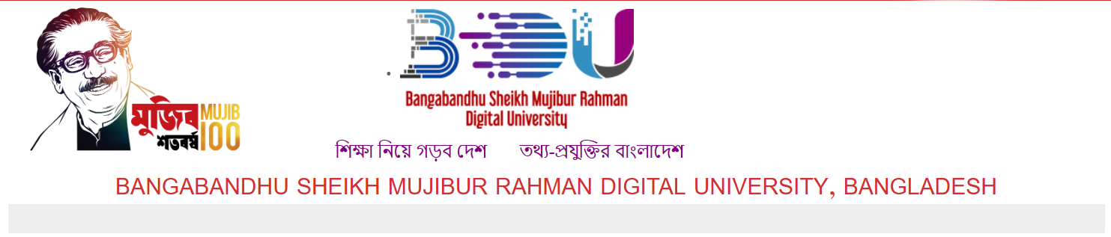

Faculty of Cyber Physical Systems.

Department of Internet of Things and Robotics Engineering.

Session: 2022-2023

Semester: 2nd

Project Proposal

Week 2 Update

Course: CSE 114

Names:

SAJID AHMED RAHI, SUYAWBID AHMMED MUAZ, ABIR KUMAR SHANTO

IDs:

2201005, 2201020, 2201023

**Metro App**

**Introduction:**

Rapid transit or mass rapid transit, also known as heavy rail or metro, is a type of high capacity public transport that is generally built in city areas.

The Dhaka Metro Rail, or simply the Dhaka Metro, is a mass rapid transit system serving Dhaka.

**Problem statement:**

People sometimes face problems while booking tickets, choosing the shortest path to the destination, getting information like, how far is the destination, ticket price, timing of metro, how much time it will take to reach the destination etc. In this project we will try to provide an application that will make it easier for the user to get the desired information and do the stuffs without any hesitation.

**Objectives:**

The main goal of this project is to simplify the process for the user to book tickets and travel by metro. User will get a friendly interface where the options like, timing, ticket price etc. will be organized properly.

Using this application user will able find the shortest path for the destination, know the approximately required time to reach the destination and book tickets by just few clicks. User will not have to stand in a line for hours to book tickets.

**Discussion:**

This project is related to data structures and algorithms. We are going to use data structure to store the station names and other required information. Algorithms will be used to sort the stations according to the destination, calculate and find the shortest path for the destination, calculate price of the ticket and calculate the required time to reach the destination.

**Applied Data Structures and Algorithms concepts:**

Various kind of Data Structures and Algorithms concepts will be applied in this project for management purposes. Such as

**Graphs:** To represent the network of Metro rail, Graph will be used where stations will be the nodes and connection between these stations will be edges.

**Priority Queues:** Will be used for route planning so that the user can find the shortest route for destination.

**Sorting Algorithms:** Will be used for Sorting, the routes according to the destination.

**Conclusion:**

In conclusion this project will help us to apply knowledge of data structures and algorithms to real world scenario, develop practical problem-solving skills, enhance coding proficiency and algorithmic thinking.